IT’S TIME FOR SUMMER READING!
We can’t wait to hear about all of the reading adventures you will take over the summer! So, share them with us! Below is a bookmark that students can use to record the books they will read this summer. Bring it back and share your reading adventures with us this fall!
Don’t forget! The Washington Elementary Library will be open on Tuesday mornings from 9-11am and Thursday afternoons from 4-6pm, beginning June 5th through July 27th (closed the week of July 4th). For summer updates and book suggestions, please visit the WE Library Blog at http://wemvlibrary.weebly.com/
Cole Library will also be offering their summer reading program loaded with opportunities for kids all summer long! You can sign up at Cole Library or at the summer kick-off event.
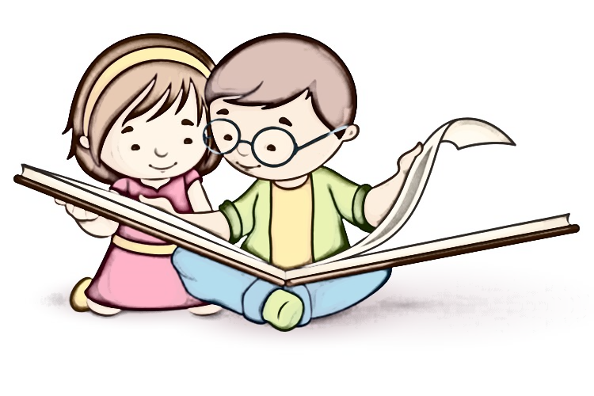
The Cole Library summer reading kick-off event will be at Hill’s Bank in Mount Vernon on May 23rd from 5-6:30pm.
Cole Library summer events schedule beginning June 5th:
Mondays: Movies at 10am
Tuesdays: Legos at 10am

Name: _____________________________

We can’t wait to hear about all of your summer reading adventures! Record what you’ve read and share your bookmark with us in August.

Two books I want to read this summer are:

_______________________________________

_______________________________________

Five books I read this summer:

_______________________________________

_______________________________________

_______________________________________

_______________________________________

_______________________________________

Wednesdays: Craft workshops at 10am
Thursdays: Storytime at 9:30am
& Paws for Reading (reading with a therapy dog) at 2-3:30 pm
BONUS SUMMER EVENTS: GOAT SINGER CHILDREN’S PROGRAM, May 27th,1pm
BLANK PARK ZOO VISIT TO COLE LIBRARY, July 20th,1pm
For more information, visit Cole Library or their website at www.colelibrary.org

